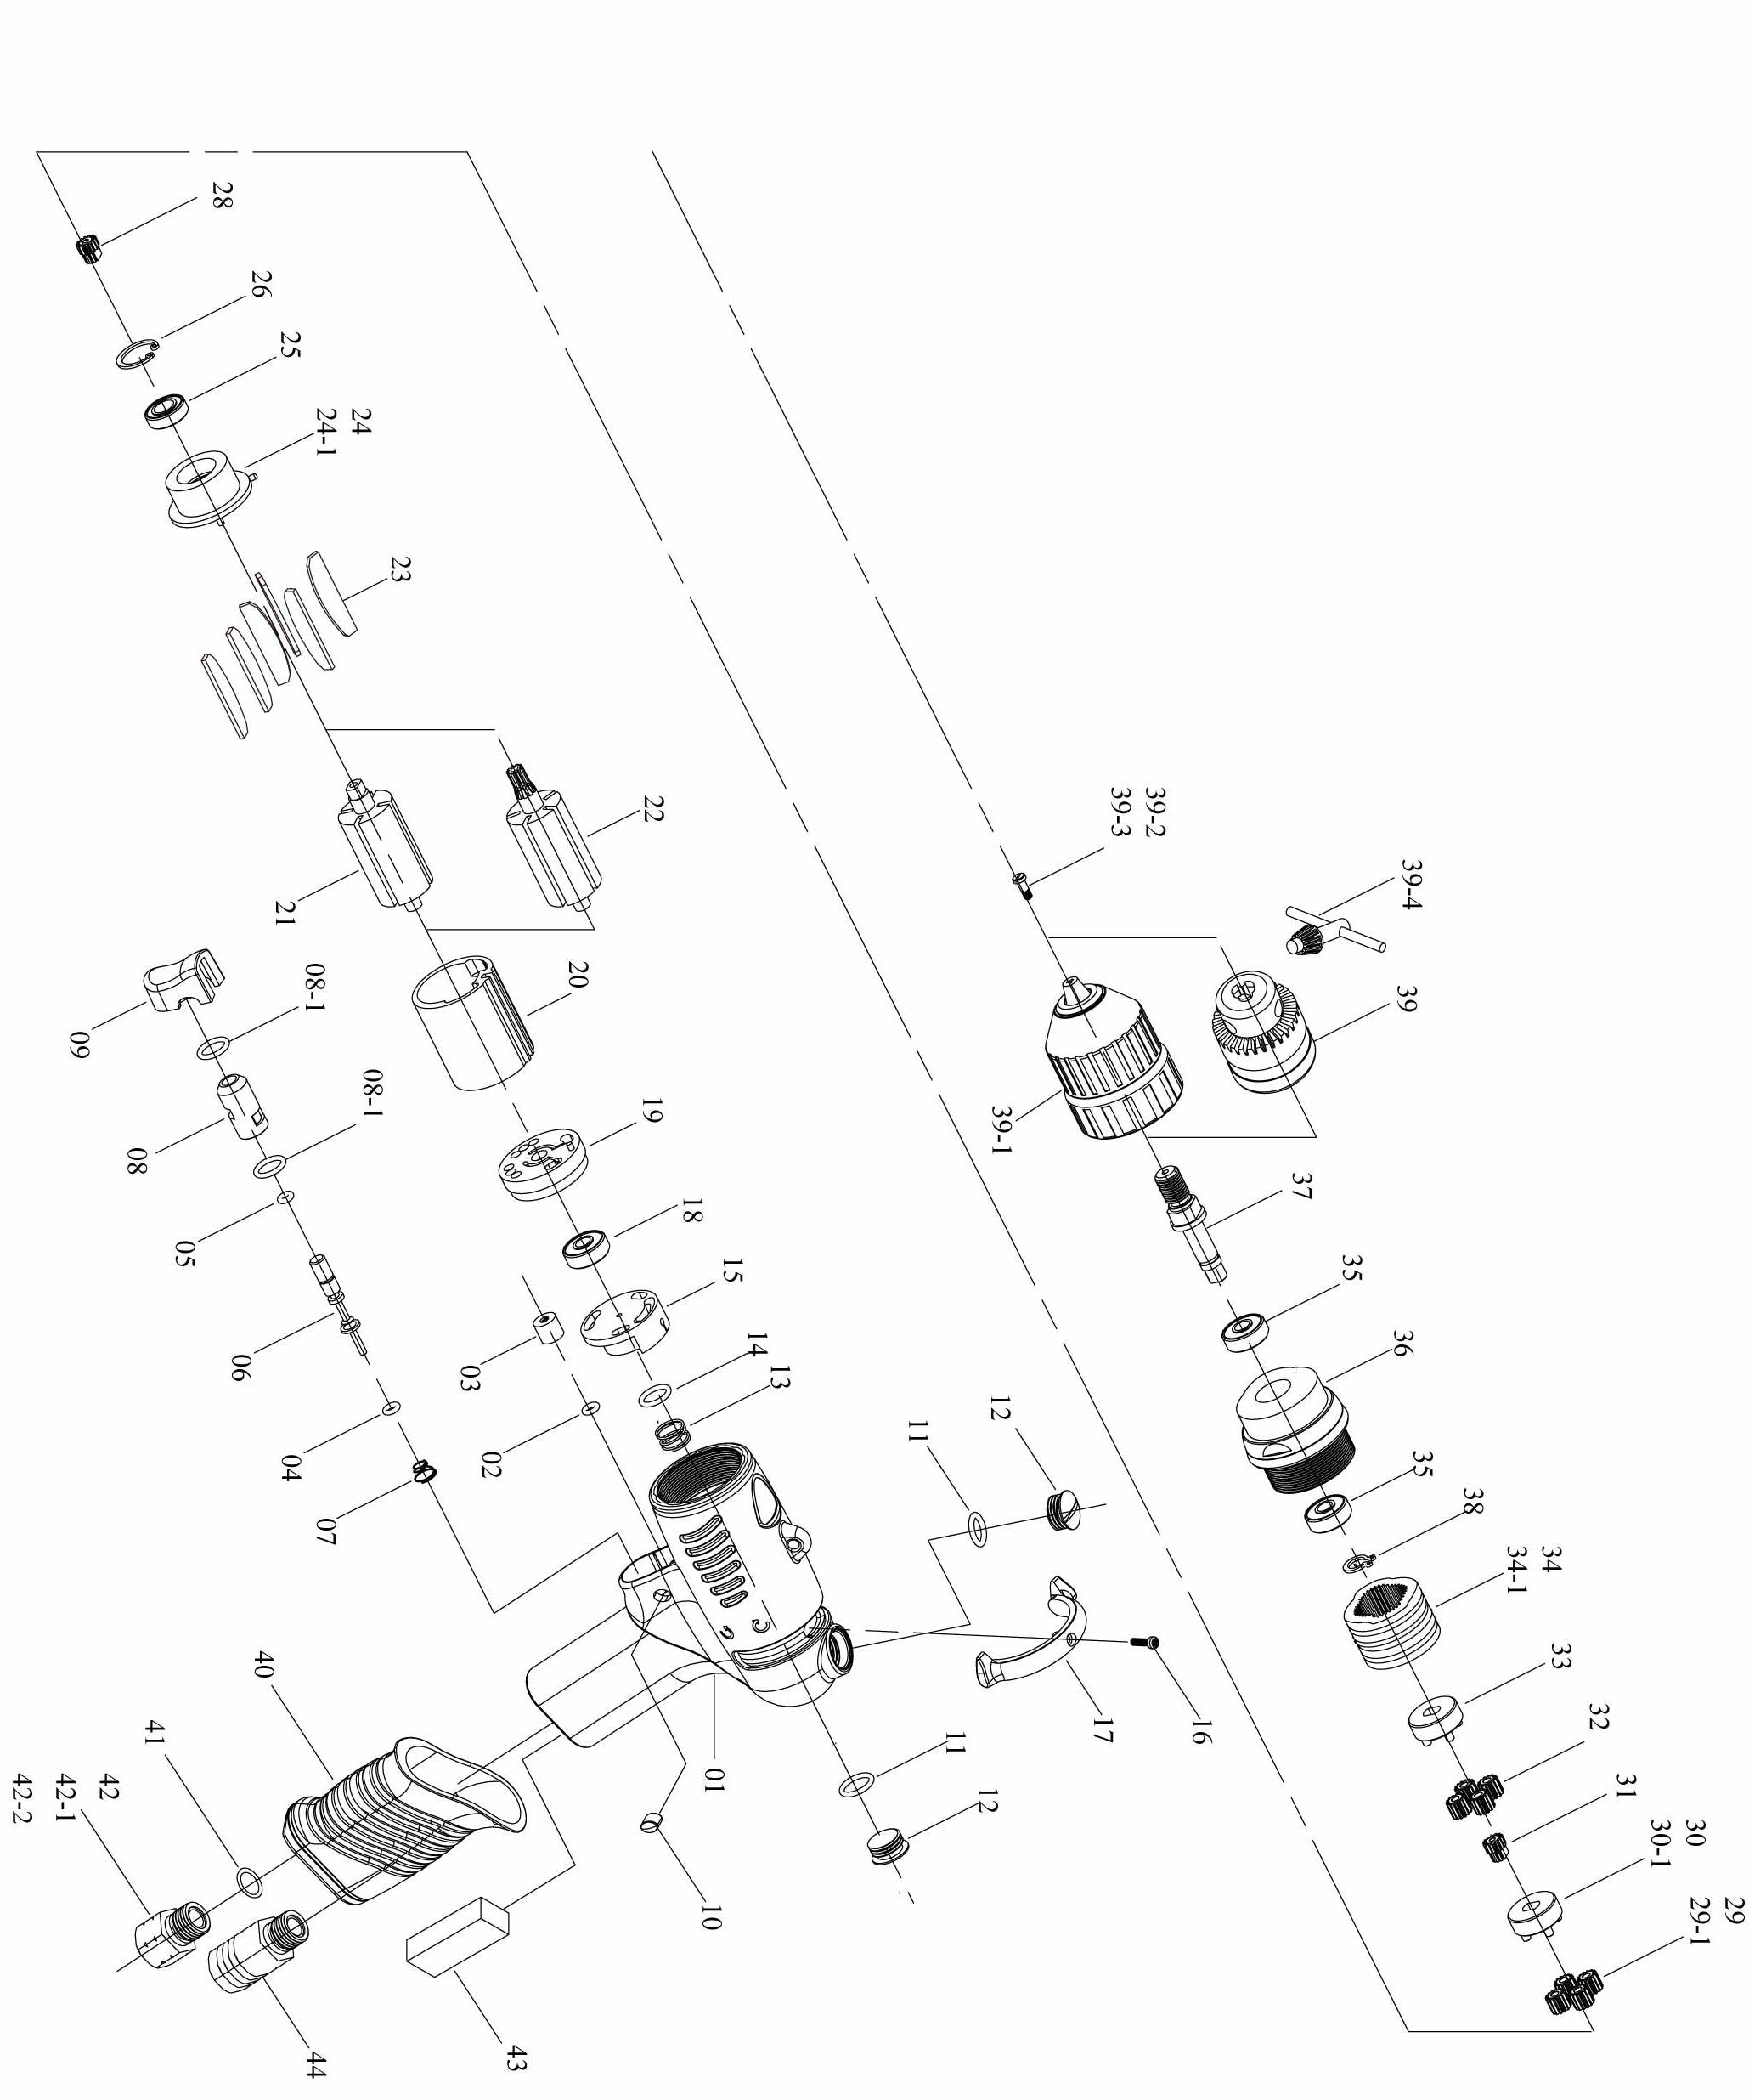

No. | Part No. | Part Name | Q’ty | No. | Part No. | Part Name | Q’ty
1 | 5L2107 | Pistol Housing | 1 | 26 | 6N2020 | C Ring [R26] | 1
2 | 7Q2008 | O Ring | 1 | 28 | 1P2275 | 18T Main Gear [R39] | 1
3 | 2C2003-A | Blank Cap | 1 | 29 | 1P2110 | 12T Plant Gear [R39] | 4
4 | 7Q2006 | O Ring | 1 | 29-1 | 1P2105 | 15T Plant Gear [R26] | 3
5 | 7Q6112 | Valve O-Ring | 1 | 30 | 1P2291 | Third Gear Cage [R39] | 1
6 | 6S2023 | Valve Pin | 1 | 30-1 | 1P5112 | Fifth Gear Cage [R26] | 1
7 | 6N2106 | Cone Spring | 1 | 31 | 1P5101 | 14T Main Gear [R39] | 1
8 | 6S2024 | Valve Bushing | 1 | 32 | 1P2131 | 14T Plant Gear [R39] | 4
8-1 | 7Q2009 | O Ring | 2 | 33 | 1P2294 | Fourth Gear Cage [R39] | 1
9 | 5L2102 | Button | 1 | 34 | 1S2069 | Internal Gear [R39] | 1
10 | 5L2112 | Cap | 2 | 34-1 | 1P2292 | Internal Gear [R26] | 1
11 | 2Q5001 | O Ring | 2 | 35 | 7S2010 | Ball Bearing | 2
12 | 2S2011 | Screw Cap | 2 | 36 | 5A5352 | Clutch Housing | 1
13 | 6N2108 | Spring | 1 | 37 | 3S5042 | Anvil | 1
14 | 7Q2017 | Valve O-Ring | 1 | 38 | 6N2081 | C Ring | 1
15 | 6S2204 | Valve | 1 | 39 | 7S3111 | Drill Chuck [R26] | 1
16 | 7S2107 | Set Screw And Washer | 1 | 39-1 | 7S3109 | Drill Chuck [R39] | 1
17 | 5L2106 | Switch | 1 | 39-2 | 7S2118 | Left Screw [R26] | 1
18 | 7S2001 | Ball Bearing | 1 | 39-3 | 7S2117 | Left Screw [R39] | 1
19 | 1S3001-A | End Plate | 1 | 39-4 | 5L3104 | Chuck Wrench [R26] | 1
20 | 1P3005 | Cylinder | 1 | 40 | 5L2105 | Pistol Cover | 1
21 | 1S3046 | Rotor [R39] | 1 | 41 | 2Q5001 | O Ring | 1
22 | 1S3048 | 7T Rotor [R26] | 1 | 42 | 2S2005 | Air Inlet Bushing [PT] | 1
23 | 1P3051 | Blade | 6 | 42-1 | 2S2008 | Air Inlet Bushing [PS] | 1
24 | 1P3062 | Front Plate [R39] | 1 | 42-2 | 2S2006 | Air Inlet Bushing [NPT] | 1
24-1 | 1P3061 | Front Plate [R26] | 1 | 43 | 2P3040 | First Silencer | 1
25 | 7S2002 | Ball Bearing | 1 | 44 | 2P3041 | Second Silencer | 1

